Online Bus Ticket Booking System
Project report submitted in partial fulfillment of the Requirements for the Award of the Degree of
BACHELOR OF COMPUTER APPLICATION
In
COMPUTER SCIENCE
By
Deekshith D Shetty ( U05YD24S0201 )

Under the Guidance of
Mrs . Shruthi T.S.


DEPARTMENT OF COMPUTER SCIENCE
ALVA’S COLLEGE (AUTONOMOUS)
A Unit of Alva’s Education Foundation (R.)
Affiliated to Mangalore University
Accredited by NAAC with ‘A’ Grade with CGPA of 3.23
Moodubudire-574227
2025

ALVA’S COLLEGE
(AUTONOMOUS)
DEPARTMENT OF COMPUTER SCIENCE



CERTIFICATE
Certified that this mini project report, Online Bus Ticket Booking System
is the bonafide work of
Deekshith D Shetty ( U05YD24S0201)
who carried out the project work under my supervision.

Mr. Ramesh
HEAD OF THE DEPARTMENT
Assistant Professor
Department of Computer Science
ALVA’S COLLEGE (AUTONOMOUS)
Affiliated to Mangalore University
Moodubudire-574227

Mrs . Shruthi T.S.
SUPERVISOR
Assistant Professor
Department of Computer Science
ALVA’S COLLEGE (AUTONOMOUS)
Affiliated to Mangalore University
Moodubudire-574227

Submitted for the Third Semester Practical Examination Mini Project
viva-voce held on / /2025

INTERNAL EXAMINER EXTERNAL EXAMINE

ACKNOWLEDGEMENT
We deem it a great privilege to present our mini project report on Online Bus Booking System. The completion of this project marks a significant milestone in our academic journey, and we owe our gratitude to all those who have contributed directly or indirectly towards its successful completion.
First and foremost, we express our deep sense of gratitude to our Guide, Mrs . Shruthi T.S.
, Department of Computer Science, Alva’s College (Autonomous), for the continuous guidance, patience, and encouragement provided throughout this project. Their valuable suggestions, constructive criticism, and expert advice at every stage have been instrumental in shaping our work and enhancing our knowledge.
We also convey our sincere thanks to our Head of the Department, Mr. Ramesh,
for providing the necessary facilities, resources, and constant encouragement that enabled us to carry out our project successfully. We extend our appreciation to all the faculty members of the Department of Computer Science for their timely assistance, motivation, and technical inputs whenever required.
Our heartfelt thanks are due to the management and administration of Alva’s Education Foundation for providing us with a conducive academic environment and infrastructure that made this project possible.
We would also like to thank our classmates and friends who have been supportive in sharing their knowledge, ideas, and feedback, which helped us refine and improve our system.
Last but not least, we owe a profound debt of gratitude to our parents and family members for their unwavering support, encouragement, and sacrifices, which have been the backbone of our academic pursuits.
This project has not only strengthened our technical skills but also taught us the importance of teamwork, planning, and persistence. We dedicate the success of this work to everyone who has helped us in this endeavour.

TABLE OF CONTENTS
S. N. | Title | Page Number
1 | Introduction
2 | Module Specification
3 | Database Design
4 | Coding
5 | Testing
6 | Output Screens
7 | Conclusion and Future scope
8 | References

CHAPTER 1
INTRODUCTION

- Introduction
The rapid growth of technology has transformed the way services are delivered, and transportation is no exception. Traditional bus booking systems are mostly manual, requiring passengers to physically visit booking counters or depend on travel agents, which is time-consuming and prone to human error. To address these issues, the Online Bus Booking System provides a convenient, efficient, and user-friendly platform that automates the process of searching buses, checking seat availability, booking tickets, making payments, and collecting feedback.
This project is designed to improve the passenger experience, reduce manual effort, and ensure transparency in booking operations, while also enabling administrators to manage buses, routes, and reservations effectively.
  - Objectives
The main objectives of the project are:
- To develop an interactive platform for online bus reservations.
- To provide secure user registration and login with input validations.
- To automate the seat selection and booking process.
- To implement OTP-based payment verification.
- To allow administrators to manage bus details, routes, and bookings.
- To integrate a feedback module to collect user opinions for future improvements.
  - Project Category
This project falls under the category of Application Software Development. It is a Windows-based desktop application built using VB.NET as the front-end and MS Access as the back-end database. The system ensures smooth interaction between users and administrators in a structured manner.

  - Hardware Requirement
- Processor: Intel i3 or higher
- RAM: 4 GB or above
- Hard Disk: Minimum 100 GB free space
- Input Devices: Keyboard, Mouse
- Display: Standard Monitor
  - Software Requirement
- Operating System: Windows 10/11
- Frontend Technology: VB.NET (Windows Forms)
- Backend Database: MS Access (UserDB.accdb)
- IDE: Microsoft Visual Studio
  - Limitation of the Project
- Works only on Windows operating systems.
- Limited scalability due to the use of MS Access as a database.
- Does not support real-time online payment gateways (simulated OTP-based payment).
- Maximum booking limit of 3 seats per user in a single transaction.
- No mobile application version is currently available.

CHAPTER 2
MODULE SPECIFICATION

- Introduction
The Online Bus Booking System is divided into multiple modules, where each module performs a specific functionality. These modules interact with each other to provide a seamless flow of operations from user registration to ticket booking, payment, and feedback collection. Each module is clearly defined in terms of its function, inputs, outputs, and integration with other parts of the system.
  - Admin Module
Function: Enables administrators to manage the system.
Features:
- Add, update, or delete bus details.
- Manage route details (origin, destination, timings).
- View booking and passenger reports.
- View and analyze user feedback.
Input: Bus details, route information.
Output: Updated database records and system reports.
  - User Registration And Login Module
Function: Allows new users to register and existing users to log in securely.
Features:
- New user registration with validations (name, mobile number, email, password).
- User login using mobile number (as username) and password.
- Password show/hide and reset features.
Input: User registration details, login credentials.
Output: User account creation or system access.

  - Bus Search And Booking Module
Function: Allows users to search available buses and book tickets.
Features:
- Search buses based on origin, destination, and travel date.
- Display available buses with seat availability and fare.
- Provide a seat layout for selection (maximum 3 seats per booking).
Input: Search parameters (origin, destination, date).
Output: Search results, seat selection confirmation.
  - Payment Module
Function: Facilitates secure ticket booking through payment validation.
Features:
- OTP (One-Time Password) generation and verification.
- Card and bank selection with card number and CVV validation.
- Stores payment details in database after confirmation.
Input: Card details, OTP, passenger details.
Output: Booking confirmation and invoice generation.
  - Feedback Module
Function: Collects user feedback on system usability and booking experience.
Features:
- Feedback form with multiple-choice and text options.
- Stores feedback in database for admin review.
- Restricts duplicate feedback submission using mobile number validation.
Input: User feedback details (name, contact, ratings, comments).
Output: Stored feedback data.

  - Reports Module
Function: Provides consolidated reports for administrators.
Features:
- Combined display of bookings and passenger details.
- Generate booking summary reports.
- Export or print reports for analysis.
Input: Stored booking and passenger database.
Output: Tabular reports displayed in DataGridView.

CHAPTER 3
DATABASE DESIGN

3.1 UsersTable:
Column Name | Data Type | Constraints | Description
UserID | AutoNumber | Primary Key | Unique identifier for each user
FirstName | Text | Not Null | User’s first name
LastName | Text | Not Null | User’s last name
Username | Number | Unique | Mobile number used as login username
Password | Text | Not Null | Encrypted user password
Email | Text | Ends with @gmail.com | User’s email address
City | Text | Not Null | User’s city
Address | Text | Optional | User’s address
Pincode | Number | 6 digits | Postal code

3.2 AdminTable:
Column Name | Data Type | Constraints | Description
AdminID | AutoNumber | Primary Key | Unique identifier for each admin
aName | Text | Unique, Not Null | Username for admin login
Apassword | Text | Not Null | Password for admin login

3.3 BusDetailsTable:
Column Name | Data Type | Constraints | Description
BusNo | Text | Primary Key | Unique bus number
BusType | Text | Check(“AC”,“Normal”) | Type of bus
SeatRows | Number | >0 | Number of seat rows
SeatCols | Number | >0 | Number of seat columns
Origin | Text | Alphabets only | Starting point
Destination | Text | Alphabets only | Ending point
BusName | Text | Not Null | Bus name
Fare | Currency | Not Null | Fare per seat
AvailableDate | Date/Time | >= Today | Date bus is available
ArrivalDate | Date/Time | Not Null | Arrival time
DepartureTime | Date/Time | Not Null | Departure time
TotalTravelTime | Date/Time | Auto-calc | Duration of travel

3.4BookingsTable:
Column Name | Data Type | Constraints | Description
BookingID | AutoNumber | Primary Key | Unique booking identifier
BusNo | Text | Foreign Key → BusDetails | Bus number booked
TravelDate | Date | Not Null | Date of travel
SeatNo | Text | Not Null | Seat number booked
FromLocation | Text | Not Null | Journey starting point
ToLocation | Text | Not Null | Journey destination
Fare | Currency | Not Null | Seat fare
Username | Number | Foreign Key → Users | User who booked the ticket

3.5PassengersTable:
Column Name | Data Type | Constraints | Description
PassengerID | AutoNumber | Primary Key | Unique identifier for each passenger
FirstName | Text | Alphabets only | Passenger’s first name
LastName | Text | Alphabets only | Passenger’s last name
Email | Text | Must be Gmail | Passenger’s email ID
Contact | Text | 10 digits | Passenger’s mobile number
City | Text | Alphabets only | Passenger’s city

3.6FeedbackDBTable:
Column Name | Data Type | Constraints | Description
FeedbackID | AutoNumber | Primary Key | Unique feedback identifier
EaseOfBooking | Text | Drop-down | User rating on booking ease
Experience | Text | Drop-down | User’s overall experience
Responsiveness | Text | Drop-down | Responsiveness of system
InfoFound | Number | Range (0–10) | User’s rating on information
FeedbackText | Text | Optional | Additional comments
SubmittedAt | Date | Default: Now() | Feedback submission time
Name | Text | Not Null | User’s name
ContactNo | Text | 10 digits | Mobile number (unique)

CHAPTER 4
CODING

User Registration Form
Imports System.Data.OleDb
Imports System.Text.RegularExpressions
Public Class Form2
' Connection to MS Access database (.accdb)
Dim con As New OleDbConnection("Provider=Microsoft.ACE.OLEDB.12.0;Data Source=C:\Users\deeks\OneDrive\Documents\Desktop\C#pro\UserDB.accdb;")
Dim cmd As OleDbCommand
Private Sub btnRegister_Click(sender As Object, e As EventArgs) Handles btnRegister.Click
Try
' 1. Check required fields
If txtFirstName.Text = "" Or txtLastName.Text = "" Or txtMobile.Text = "" Or txtPassword.Text = "" Or txtConfirmPassword.Text = "" Then
MessageBox.Show("Please fill all required fields!", "Warning", MessageBoxButtons.OK, MessageBoxIcon.Warning)
Exit Sub
End If
' 2. Validate names and city
If Not Regex.IsMatch(txtFirstName.Text, "^[A-Za-z]+$") Then
MessageBox.Show("Firstname must contain only alphabets.", "Invalid Input", MessageBoxButtons.OK, MessageBoxIcon.Warning)
Exit Sub
End If
If Not Regex.IsMatch(txtLastName.Text, "^[A-Za-z]+$") Then
MessageBox.Show("Lastname must contain only alphabets.", "Invalid Input", MessageBoxButtons.OK, MessageBoxIcon.Warning)
Exit Sub
End If
If Not Regex.IsMatch(txtCity.Text, "^[A-Za-z\s]+$") Then
MessageBox.Show("City must contain only alphabets.", "Invalid Input", MessageBoxButtons.OK, MessageBoxIcon.Warning)
Exit Sub
End If
' 3. Validate mobile number (10 digits)
If Not Regex.IsMatch(txtMobile.Text, "^\d{10}$") Then
MessageBox.Show("Mobile number must be exactly 10 digits.", "Invalid Input", MessageBoxButtons.OK, MessageBoxIcon.Warning)
Exit Sub
End If
' 4. Validate email
If Not txtEmail.Text.EndsWith("@gmail.com") Then
MessageBox.Show("Email must end with @gmail.com", "Invalid Email", MessageBoxButtons.OK, MessageBoxIcon.Warning)
Exit Sub
End If

' 5. Validate pincode (6 digits)
If Not Regex.IsMatch(txtPincode.Text, "^\d{6}$") Then
MessageBox.Show("Pincode must be exactly 6 digits.", "Invalid Input", MessageBoxButtons.OK, MessageBoxIcon.Warning)
Exit Sub
End If
' 6. Password confirmation
If txtPassword.Text <> txtConfirmPassword.Text Then
MessageBox.Show("Password and Confirm Password do not match.", "Mismatch", MessageBoxButtons.OK, MessageBoxIcon.Warning)
Exit Sub
End If
con.Open()
' 7. Check if user exists
Dim checkQuery As String = "SELECT COUNT(*) FROM Users WHERE Username = @Username"
Dim checkCmd As New OleDbCommand(checkQuery, con)
checkCmd.Parameters.AddWithValue("@Username", Convert.ToInt64(txtMobile.Text))
Dim exists As Integer = CInt(checkCmd.ExecuteScalar())
If exists > 0 Then
MessageBox.Show("This mobile number is already registered.", "Duplicate Entry", MessageBoxButtons.OK, MessageBoxIcon.Warning)
con.Close()
Exit Sub
End If
' 8. Insert into database (ConfirmPassword not stored)
Dim query As String = "INSERT INTO Users (Firstname, LastName, Username, [Password], Email, City, Address, Pincode) " &
"VALUES (@Firstname, @LastName, @Username, @Password, @Email, @City, @Address, @Pincode)"
cmd = New OleDbCommand(query, con)
cmd.Parameters.AddWithValue("@Firstname", txtFirstName.Text)
cmd.Parameters.AddWithValue("@LastName", txtLastName.Text)
cmd.Parameters.AddWithValue("@Username", Convert.ToInt64(txtMobile.Text))
cmd.Parameters.AddWithValue("@Password", txtPassword.Text)
cmd.Parameters.AddWithValue("@Email", txtEmail.Text)
cmd.Parameters.AddWithValue("@City", txtCity.Text)
cmd.Parameters.AddWithValue("@Address", txtAddress.Text)
cmd.Parameters.AddWithValue("@Pincode", txtPincode.Text)
cmd.ExecuteNonQuery()
MessageBox.Show("Registration Successful!", "Success", MessageBoxButtons.OK, MessageBoxIcon.Information)
ClearForm()
Catch ex As Exception
MessageBox.Show("Error: " & ex.Message, "Exception", MessageBoxButtons.OK, MessageBoxIcon.Error)
Finally
If con.State = ConnectionState.Open Then con.Close()
End Try
End Sub
' Clear all fields
Private Sub ClearForm()
txtFirstName.Clear()
txtLastName.Clear()
txtMobile.Clear()
txtPassword.Clear()
txtConfirmPassword.Clear()
txtEmail.Clear()
txtCity.Clear()
txtAddress.Clear()
txtPincode.Clear()
txtFirstName.Focus()
End Sub
' Show/Hide Password
Private passwordShown As Boolean = False
Private Sub Form2_Load(sender As Object, e As EventArgs) Handles MyBase.Load
txtPassword.PasswordChar = "•"c
txtConfirmPassword.PasswordChar = "•"c
btnTogglePassword.Text = "Show"
passwordShown = False
End Sub
Private Sub btnTogglePassword_Click(sender As Object, e As EventArgs) Handles btnTogglePassword.Click
If passwordShown Then
txtPassword.PasswordChar = "•"c
txtConfirmPassword.PasswordChar = "•"c
btnTogglePassword.Text = "Show"
passwordShown = False
Else
txtPassword.PasswordChar = Nothing
txtConfirmPassword.PasswordChar = Nothing
btnTogglePassword.Text = "Hide"
passwordShown = True
End If
End Sub
' Navigation button
Private Sub Button1_Click(sender As Object, e As EventArgs) Handles Button1.Click
Form1.Show()
Form1.BringToFront()
Form1.Activate()
Me.Hide()
End Sub
Private Sub btnLogin_Click(sender As Object, e As EventArgs) Handles btnLogin.Click
Form10.Show()
Form10.BringToFront()
Form10.Activate()
Me.Hide()
End Sub
' =======================
' MOBILE TEXTBOX HANDLERS
' =======================
' Only allow 10 digits when typing
Private Sub txtMobile_KeyPress(sender As Object, e As KeyPressEventArgs) Handles txtMobile.KeyPress
If Char.IsControl(e.KeyChar) Then
Return
End If
If Not Char.IsDigit(e.KeyChar) OrElse txtMobile.TextLength >= 10 Then
e.Handled = True
End If
End Sub
' Clean up pasted values or typing errors
Private Sub txtMobile_TextChanged(sender As Object, e As EventArgs) Handles txtMobile.TextChanged
Dim digitsOnly As String = New String(txtMobile.Text.Where(Function(c) Char.IsDigit(c)).ToArray())
If digitsOnly.Length > 10 Then
digitsOnly = digitsOnly.Substring(0, 10)
End If
If txtMobile.Text <> digitsOnly Then
Dim pos = txtMobile.SelectionStart
txtMobile.Text = digitsOnly
txtMobile.SelectionStart = Math.Min(pos, digitsOnly.Length)
End If
End Sub
End Class

Add Bus Details Form

Imports System.Data.OleDb
Imports System.Text.RegularExpressions
Public Class addbus

' Access database connection string
Private ReadOnly conStr As String =
"Provider=Microsoft.ACE.OLEDB.12.0;Data Source=C:\Users\deeks\OneDrive\Documents\Desktop\C#pro\UserDB.accdb;"
Private Sub addbus_Load(sender As Object, e As EventArgs) Handles MyBase.Load
cboBusType.DropDownStyle = ComboBoxStyle.DropDownList
cboBusType.Items.Clear()
cboBusType.Items.AddRange(New Object() {"AC", "Normal"})
cboBusType.SelectedIndex = 0

' Setup DateTimePickers for time only
dtpArrival.Format = DateTimePickerFormat.Custom
dtpArrival.CustomFormat = "HH:mm"
dtpArrival.ShowUpDown = True

dtpDeparture.Format = DateTimePickerFormat.Custom
dtpDeparture.CustomFormat = "HH:mm"
dtpDeparture.ShowUpDown = True

dtpTravelTime.Format = DateTimePickerFormat.Custom
dtpTravelTime.CustomFormat = "HH:mm"
dtpTravelTime.ShowUpDown = True
dtpTravelTime.Enabled = False ' Disable manual editing of travel time

dtpAvailable.Format = DateTimePickerFormat.Short
dtpAvailable.MinDate = DateTime.Today ' Restrict to today or future dates

' Initial calculation for travel time
RecalculateTravelTime()
End Sub

' === AUTO CALCULATE TRAVEL TIME ===
Private Sub RecalculateTravelTime()
Dim departure As DateTime = dtpDeparture.Value
Dim arrival As DateTime = dtpArrival.Value

' If arrival is earlier than departure, assume next day
If arrival < departure Then
arrival = arrival.AddDays(1)
End If

Dim duration As TimeSpan = arrival - departure
Dim formatted As DateTime = DateTime.Today.Add(duration)
dtpTravelTime.Value = formatted
End Sub

' When arrival or departure time changes, recalculate
Private Sub dtpArrival_ValueChanged(sender As Object, e As EventArgs) Handles dtpArrival.ValueChanged
RecalculateTravelTime()
End Sub
Private Sub dtpDeparture_ValueChanged(sender As Object, e As EventArgs) Handles dtpDeparture.ValueChanged
RecalculateTravelTime()
End Sub

' === INSERT BUTTON ===
Private Sub btnInsert_Click(sender As Object, e As EventArgs) Handles btnInsert.Click
Dim rows As Integer, cols As Integer, fare As Decimal

' === Input Validations ===
If String.IsNullOrWhiteSpace(txtBusNo.Text) OrElse Not Regex.IsMatch(txtBusNo.Text.Trim(), "^\d+$") Then
MessageBox.Show("Bus No is required and must contain digits only.") : txtBusNo.Focus() : Exit Sub
End If

If Not Integer.TryParse(txtSeatRows.Text, rows) OrElse rows <= 0 Then
MessageBox.Show("Enter a valid number for Seat Rows.") : txtSeatRows.Focus() : Exit Sub
End If

If Not Integer.TryParse(txtSeatCols.Text, cols) OrElse cols <= 0 Then
MessageBox.Show("Enter a valid number for Seat Columns.") : txtSeatCols.Focus() : Exit Sub
End If

If String.IsNullOrWhiteSpace(txtOrigin.Text) OrElse Not Regex.IsMatch(txtOrigin.Text.Trim(), "^[A-Za-z\s]+$") Then
MessageBox.Show("Origin must contain only letters.") : txtOrigin.Focus() : Exit Sub
End If

If String.IsNullOrWhiteSpace(txtDestination.Text) OrElse Not Regex.IsMatch(txtDestination.Text.Trim(), "^[A-Za-z\s]+$") Then
MessageBox.Show("Destination must contain only letters.") : txtDestination.Focus() : Exit Sub
End If

If String.IsNullOrWhiteSpace(txtBusName.Text) OrElse Not Regex.IsMatch(txtBusName.Text.Trim(), "^[A-Za-z\s]+$") Then
MessageBox.Show("Bus Name must contain only letters.") : txtBusName.Focus() : Exit Sub
End If

If Not Decimal.TryParse(txtFare.Text.Trim(), fare) Then
MessageBox.Show("Enter a valid number for Fare.") : txtFare.Focus() : Exit Sub
End If

' === Prepare values ===
Dim availableDate As Date = dtpAvailable.Value.Date
Dim arrivalTime As String = dtpArrival.Value.ToString("HH:mm")
Dim departureTime As String = dtpDeparture.Value.ToString("HH:mm")
Dim travelTime As String = dtpTravelTime.Value.ToString("HH:mm")

' === Insert into DB ===
Try
Using con As New OleDbConnection(conStr)
con.Open()

' Check duplicate BusNo
Using chk As New OleDbCommand("SELECT COUNT(*) FROM BusDetails WHERE BusNo = ?", con)
chk.Parameters.AddWithValue("?", txtBusNo.Text.Trim())
If CInt(chk.ExecuteScalar()) > 0 Then
MessageBox.Show("This Bus No already exists.") : Exit Sub
End If
End Using

' Insert query
Using cmd As New OleDbCommand("INSERT INTO BusDetails (BusNo, BusType, SeatRows, SeatCols, Origin, Destination, BusName, Fare, AvailableDate, ArrivalDate, DepartureTime, TotalTravelTime) VALUES (?, ?, ?, ?, ?, ?, ?, ?, ?, ?, ?, ?)", con)
cmd.Parameters.AddWithValue("?", txtBusNo.Text.Trim())
cmd.Parameters.AddWithValue("?", cboBusType.SelectedItem.ToString())
cmd.Parameters.AddWithValue("?", rows)
cmd.Parameters.AddWithValue("?", cols)
cmd.Parameters.AddWithValue("?", txtOrigin.Text.Trim())
cmd.Parameters.AddWithValue("?", txtDestination.Text.Trim())
cmd.Parameters.AddWithValue("?", txtBusName.Text.Trim())
cmd.Parameters.AddWithValue("?", fare)
cmd.Parameters.AddWithValue("?", availableDate)
cmd.Parameters.AddWithValue("?", arrivalTime)
cmd.Parameters.AddWithValue("?", departureTime)
cmd.Parameters.AddWithValue("?", travelTime)

cmd.ExecuteNonQuery()
End Using
End Using

MessageBox.Show("Bus added successfully!")

' Clear form
txtBusNo.Clear()
txtSeatRows.Clear()
txtSeatCols.Clear()
txtOrigin.Clear()
txtDestination.Clear()
txtBusName.Clear()
txtFare.Clear()
cboBusType.SelectedIndex = 0
txtBusNo.Focus()

Catch ex As Exception
MessageBox.Show("Insert failed: " & ex.Message)
End Try
End Sub

' VIEW ALL
Private Sub btnViewAll_Click(sender As Object, e As EventArgs) Handles btnViewAll.Click
Form6.Show()
Form6.BringToFront()
Form6.Activate()
Me.Hide()

End Sub

' BACK
Private Sub Button1_Click(sender As Object, e As EventArgs) Handles Button1.Click
Form4.Show()
Form4.BringToFront()
Form4.Activate()
Me.Hide()

End Sub

' === KEYBOARD VALIDATIONS ===
' BusNo: Digits only
Private Sub txtBusNo_KeyPress(sender As Object, e As KeyPressEventArgs) Handles txtBusNo.KeyPress
If Not Char.IsDigit(e.KeyChar) AndAlso Not Char.IsControl(e.KeyChar) Then e.Handled = True
End Sub

' SeatRows and SeatCols: Digits only
Private Sub txtSeatRows_KeyPress(sender As Object, e As KeyPressEventArgs) Handles txtSeatRows.KeyPress
If Not Char.IsDigit(e.KeyChar) AndAlso Not Char.IsControl(e.KeyChar) Then e.Handled = True
End Sub

Private Sub txtSeatCols_KeyPress(sender As Object, e As KeyPressEventArgs) Handles txtSeatCols.KeyPress
If Not Char.IsDigit(e.KeyChar) AndAlso Not Char.IsControl(e.KeyChar) Then e.Handled = True
End Sub

' Fare: Digits, one dot allowed
Private Sub txtFare_KeyPress(sender As Object, e As KeyPressEventArgs) Handles txtFare.KeyPress
If Not Char.IsDigit(e.KeyChar) AndAlso Not Char.IsControl(e.KeyChar) AndAlso e.KeyChar <> "."c Then
e.Handled = True
ElseIf e.KeyChar = "."c AndAlso txtFare.Text.Contains(".") Then
e.Handled = True
End If
End Sub

' Origin, Destination, BusName: Letters and space only
Private Sub AlphabetOnly_KeyPress(sender As Object, e As KeyPressEventArgs) Handles txtOrigin.KeyPress, txtDestination.KeyPress, txtBusName.KeyPress
If Not Char.IsLetter(e.KeyChar) AndAlso Not Char.IsControl(e.KeyChar) AndAlso e.KeyChar <> " "c Then
e.Handled = True
End If
End Sub

' === LOAD BUS DETAILS FROM BUS NO ===
Public Sub LoadBusDetails(busNo As String)
Try
Using con As New OleDbConnection(conStr)
con.Open()
Dim query As String = "SELECT * FROM BusDetails WHERE BusNo = ?"
Using cmd As New OleDbCommand(query, con)
cmd.Parameters.AddWithValue("?", busNo)
Using reader As OleDbDataReader = cmd.ExecuteReader()
If reader.Read() Then
txtBusNo.Text = reader("BusNo").ToString()
cboBusType.SelectedItem = reader("BusType").ToString()
txtSeatRows.Text = reader("SeatRows").ToString()
txtSeatCols.Text = reader("SeatCols").ToString()
txtOrigin.Text = reader("Origin").ToString()
txtDestination.Text = reader("Destination").ToString()
txtBusName.Text = reader("BusName").ToString()
txtFare.Text = reader("Fare").ToString()

' Set AvailableDate to date only (time = 00:00:00)
dtpAvailable.Value = Convert.ToDateTime(reader("AvailableDate")).Date

dtpArrival.Value = DateTime.Today.Add(TimeSpan.Parse(reader("ArrivalDate").ToString()))
dtpDeparture.Value = DateTime.Today.Add(TimeSpan.Parse(reader("DepartureTime").ToString()))
dtpTravelTime.Value = DateTime.Today.Add(TimeSpan.Parse(reader("TotalTravelTime").ToString()))
Else
MessageBox.Show("Bus not found.")
End If
End Using
End Using
End Using
Catch ex As Exception
MessageBox.Show("Failed to load bus details: " & ex.Message)
End Try
End Sub

End Class

Seat Booking Form

Imports System.Data.OleDb
Public Class Form13
Public Property BusNo As String
Public Property FromLocation As String
Public Property ToLocation As String
Public Property TravelDate As Date
Public Property Username As String
Private ReadOnly conStr As String =
"Provider=Microsoft.ACE.OLEDB.12.0;Data Source=C:\Users\deeks\OneDrive\Documents\Desktop\C#pro\UserDB.accdb;"
Private SeatButtons As New Dictionary(Of String, Button)
Public SelectedSeats As New List(Of String)
Public FarePerSeat As Decimal = 0D
Private MaxSeatsAllowed As Integer = 3
Private Sub Form13_Load(sender As Object, e As EventArgs) Handles MyBase.Load
ResetForm()
' Make TextBoxes read-only and visually non-editable
For Each tb As TextBox In {txtFrom, txtTo, txtTravelDate, txtSelectedSeats, txtFarePerSeat, txtTotalFare}
tb.ReadOnly = True
tb.TabStop = False ' Prevent tab focus
tb.BorderStyle = BorderStyle.None ' Remove border
tb.BackColor = Me.BackColor ' Match form background
tb.Cursor = Cursors.Default ' Default cursor (no I-beam)
Next
txtFrom.Text = FromLocation
txtTo.Text = ToLocation
txtTravelDate.Text = TravelDate.ToShortDateString()
PanelSeats.AutoScroll = True
LoadFare()
GenerateSeats()
LoadBookedSeats()
UpdateSummary()
End Sub
Private Sub ResetForm()
SelectedSeats.Clear()
txtSelectedSeats.Text = ""
txtTotalFare.Text = "0.00"
txtFarePerSeat.Text = "0.00"
For Each btn In SeatButtons.Values
btn.BackColor = Color.LightBlue
btn.Enabled = True
Next
End Sub
Private Sub LoadFare()
Try
Using con As New OleDbConnection(conStr)
con.Open()
Dim cmd As New OleDbCommand("SELECT Fare FROM BusDetails WHERE BusNo = ?", con)
cmd.Parameters.AddWithValue("?", BusNo)
Dim result = cmd.ExecuteScalar()
If result IsNot Nothing Then
FarePerSeat = Convert.ToDecimal(result)
txtFarePerSeat.Text = FarePerSeat.ToString("0.00")
End If
End Using
Catch ex As Exception
MessageBox.Show("Error loading fare: " & ex.Message)
End Try
End Sub
Private Sub GenerateSeats()
PanelSeats.Controls.Clear()
SeatButtons.Clear()
Dim rows As Integer = 0
Dim cols As Integer = 0
Try
Using con As New OleDbConnection(conStr)
con.Open()
Dim cmd As New OleDbCommand("SELECT SeatRows, SeatCols FROM BusDetails WHERE BusNo = ?", con)
cmd.Parameters.AddWithValue("?", BusNo)
Using reader As OleDbDataReader = cmd.ExecuteReader()
If reader.Read() Then
rows = Convert.ToInt32(reader("SeatRows"))
cols = Convert.ToInt32(reader("SeatCols"))
End If
End Using
End Using
Catch ex As Exception
MessageBox.Show("Error fetching seat layout: " & ex.Message)
Return
End Try
Dim startX As Integer = 20
Dim startY As Integer = 20
Dim btnSize As Integer = 40
Dim gap As Integer = 5
Dim seatCounter As Integer = 1
For r As Integer = 1 To rows
For c As Integer = 1 To cols
Dim seatNo As String = seatCounter.ToString()
Dim btn As New Button()
btn.Name = "btn" & seatNo
btn.Text = seatNo
btn.Width = btnSize
btn.Height = btnSize
btn.Left = startX + (c - 1) * (btnSize + gap)
btn.Top = startY + (r - 1) * (btnSize + gap)
btn.BackColor = Color.LightBlue
AddHandler btn.Click, AddressOf Seat_Click
PanelSeats.Controls.Add(btn)
SeatButtons(seatNo) = btn
seatCounter += 1
Next
Next
End Sub
Private Sub LoadBookedSeats()
Try
Using con As New OleDbConnection(conStr)
con.Open()
Dim cmd As New OleDbCommand("SELECT SeatNo FROM Bookings WHERE BusNo = ? AND TravelDate = ?", con)
cmd.Parameters.AddWithValue("?", BusNo)
cmd.Parameters.AddWithValue("?", TravelDate)

Using reader = cmd.ExecuteReader()
While reader.Read()
Dim seat As String = reader("SeatNo").ToString()
If SeatButtons.ContainsKey(seat) Then
SeatButtons(seat).BackColor = Color.Red
SeatButtons(seat).Enabled = False
End If
End While
End Using
End Using
Catch ex As Exception
MessageBox.Show("Error loading booked seats: " & ex.Message)
End Try
End Sub
Private Sub Seat_Click(sender As Object, e As EventArgs)
Dim btn As Button = CType(sender, Button)
Dim seatNo As String = btn.Text
If btn.BackColor = Color.LightBlue Then
If SelectedSeats.Count >= MaxSeatsAllowed Then
MessageBox.Show("You can select only up to 3 seats per person.")
Return
End If
btn.BackColor = Color.Black
SelectedSeats.Add(seatNo)
ElseIf btn.BackColor = Color.Black Then
btn.BackColor = Color.LightBlue
SelectedSeats.Remove(seatNo)
End If
UpdateSummary()
End Sub
Private Sub UpdateSummary()
txtSelectedSeats.Text = String.Join(",", SelectedSeats)
Dim total As Decimal = SelectedSeats.Count * FarePerSeat
txtTotalFare.Text = total.ToString("0.00")
End Sub
Private Sub btnBook_Click(sender As Object, e As EventArgs) Handles btnBook.Click
If SelectedSeats.Count = 0 Then
MessageBox.Show("Please select at least one seat.")
Return
End If
Dim paymentForm As New Form14()
paymentForm.TotalFare = SelectedSeats.Count * FarePerSeat
paymentForm.SeatList = SelectedSeats
paymentForm.Username = Me.Username
paymentForm.BusNo = Me.BusNo
paymentForm.TravelDate = Me.TravelDate
paymentForm.FromLocation = Me.FromLocation
paymentForm.ToLocation = Me.ToLocation
paymentForm.FarePerSeat = Me.FarePerSeat
paymentForm.Show()
Me.Hide()
End Sub
Private Sub Button1_Click(sender As Object, e As EventArgs) Handles Button1.Click
Form10.Show()
Me.Hide()
End Sub
End Class

CHAPTER 5
TESTING

5.1 Test Scenarios and Test Cases
Test Scenarios | Test Steps | Expected Result | Status
User Registration with Valid Data | Enter valid details (First name, Last name, 10-digit mobile, email, password) → Click Register | Registration successful, user record stored in DB | Successfully
User Registration with Duplicate Mobile No. | Enter already registered mobile no. → Click Register | Error message “Mobile number already registered” | Successfully
Login with Correct Credentials | Enter valid username and password → Click Login | Redirect to user dashboard | Successfully
Login with Wrong Password | Enter valid username but wrong password | Error “Invalid Username or Password” | Successfully
Bus Search with Valid Route | Select valid From, To, Date → Click Search | List of available buses displayed | Successfully
Bus Search with Same From & To | Select same location in both fields | Error message “Origin and Destination cannot be the same” | Successfully
Seat Selection (≤3 seats) | Select up to 3 seats → Proceed to book | Seats selected successfully | Successfully
Seat Selection (>3 seats) | Select more than 3 seats → Proceed | Error “You can select only up to 3 seats per person” | Successfully
Payment with Valid OTP | Enter valid 6-digit OTP → Submit | Payment successful, booking confirmed | Successfully
Payment with Invalid OTP | Enter wrong OTP | Error message “Invalid OTP. Please try again.” | Successfully
Feedback Submission (Valid) | Enter valid name, 10-digit mobile, select ratings → Submit | Feedback stored successfully | Successfully
Feedback Duplicate Entry | Try submitting feedback again with same mobile number | Error “Feedback already submitted for this mobile number” | Successfully
Admin Login (Valid) | Enter correct admin name & password | Redirect to Admin Dashboard | Successfully
Admin Login (Invalid) | Enter wrong details | Error “Username not found/Incorrect password” | Successfully
Booking Report Generation | Click “Booking Report” in Admin Dashboard | Combined bookings + passenger data displayed in DataGridView | Successfully

CHAPTER 6
OUTPUT SCREENS

1 . Main Page 2 . Admin Login
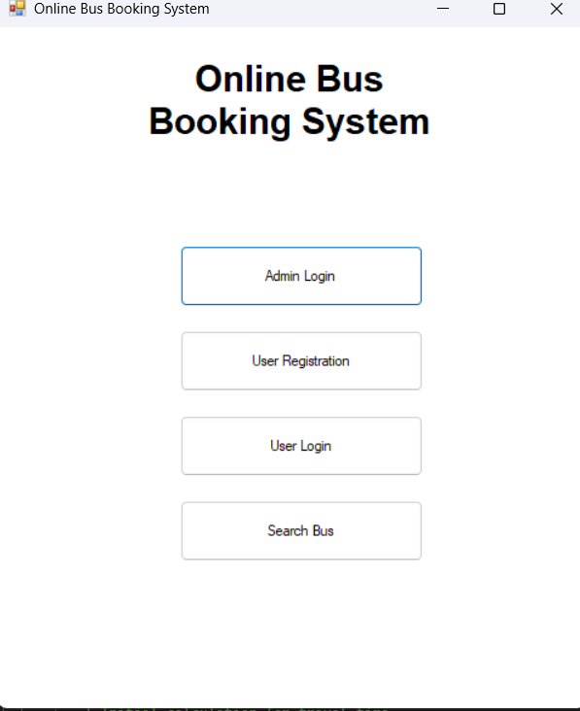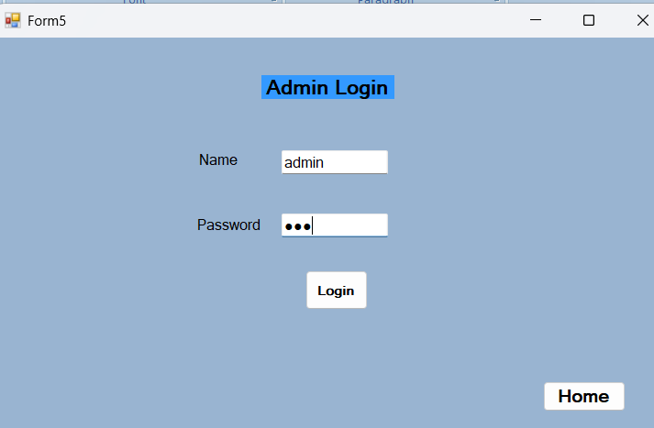

3 . Admin Dashboard 4 . Add bus details
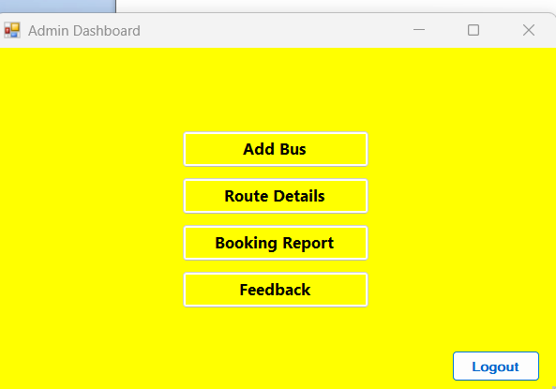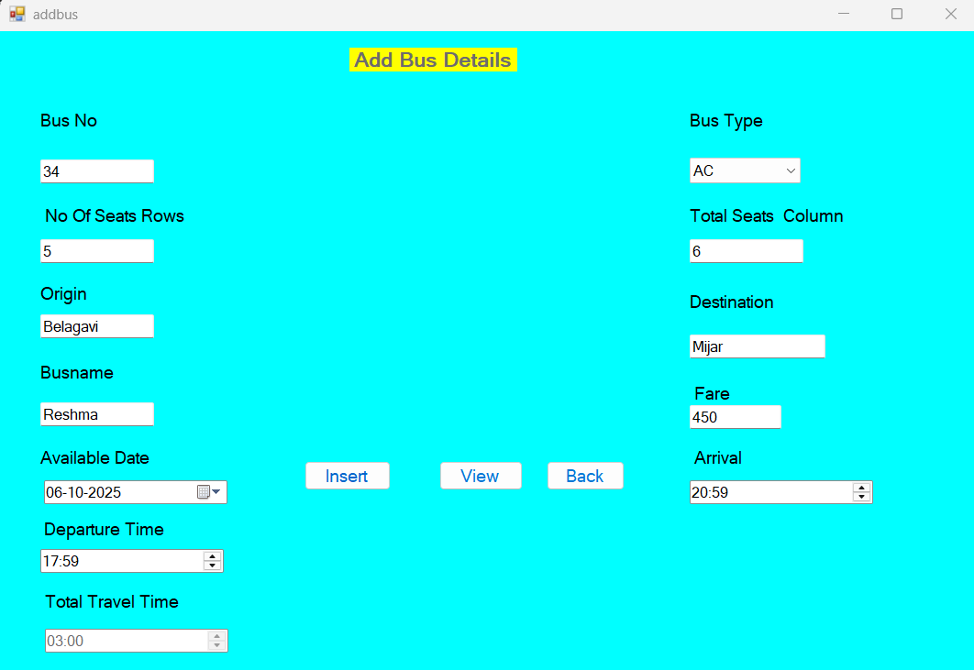

5 . Route Details
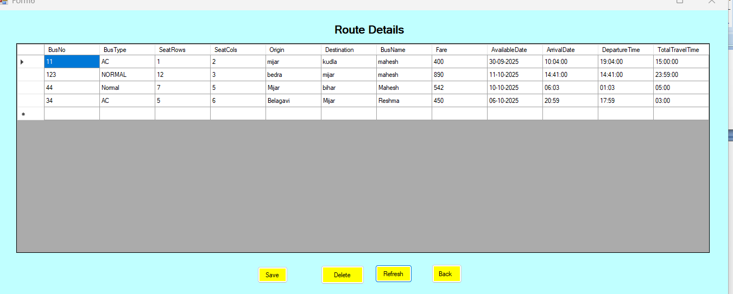
6. Booking Report
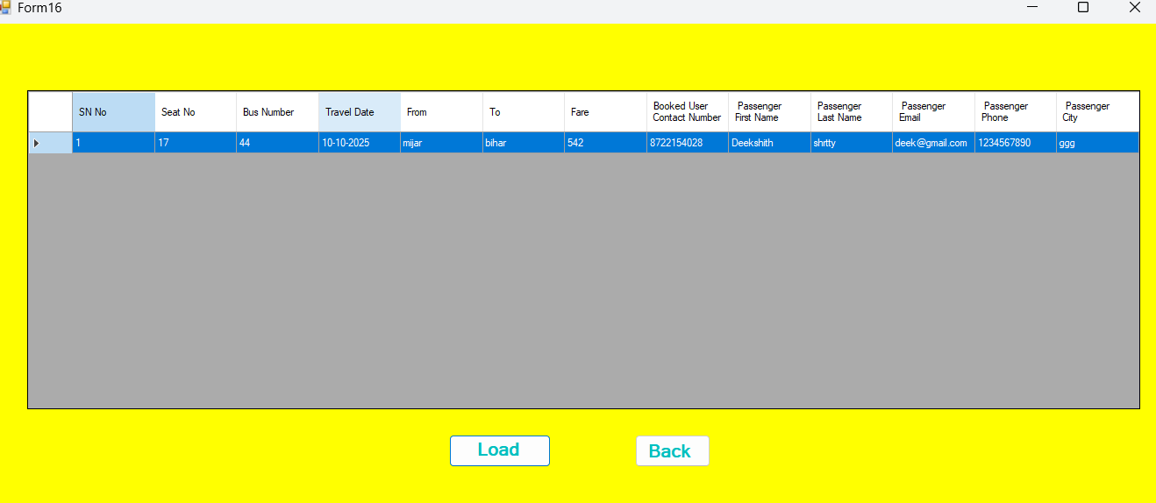
7. Feedback
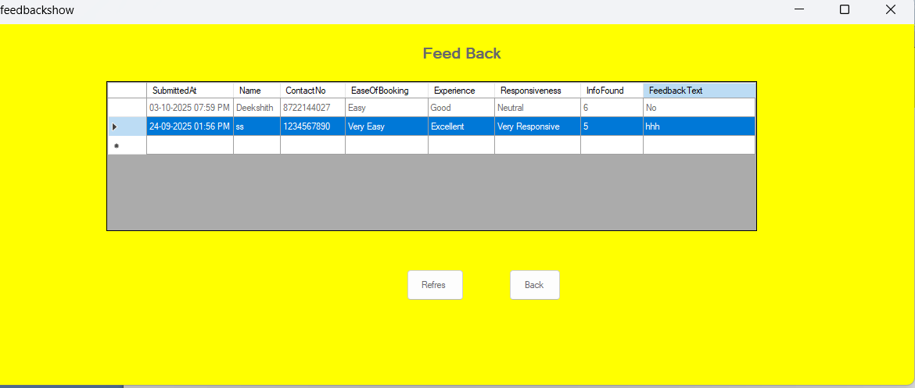

8. User Registration 9. User Login
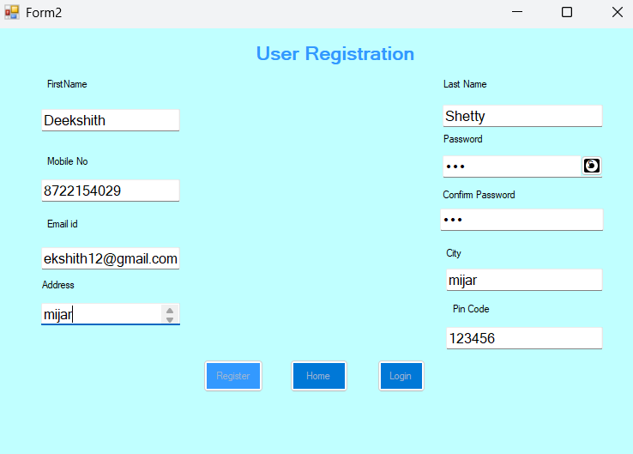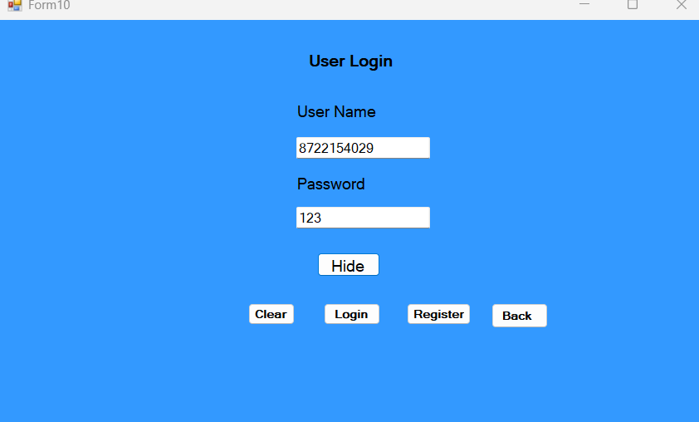

10. Search Bus 11. Select Bus
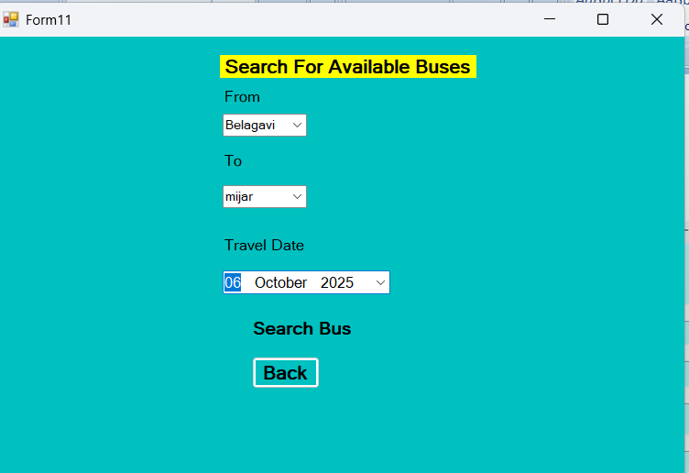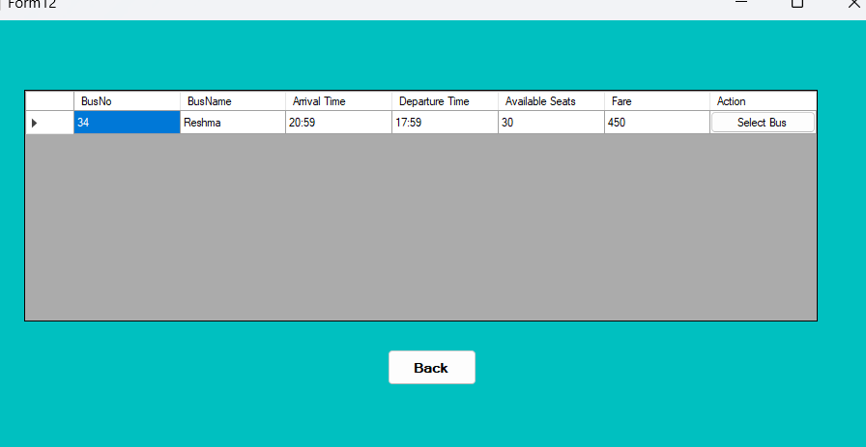

12. Seat Booking 13. Passenger and Payment Detail
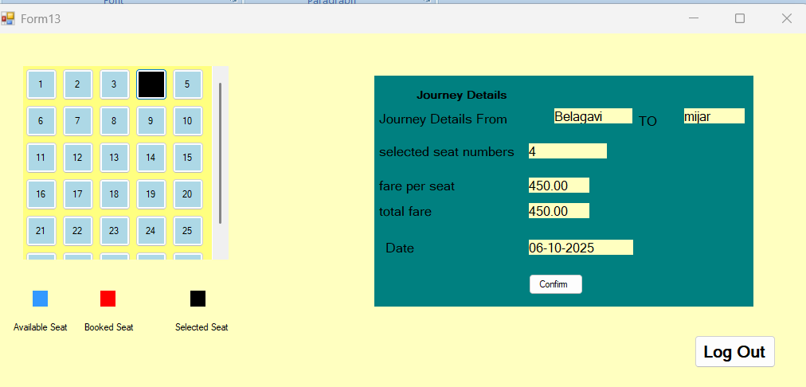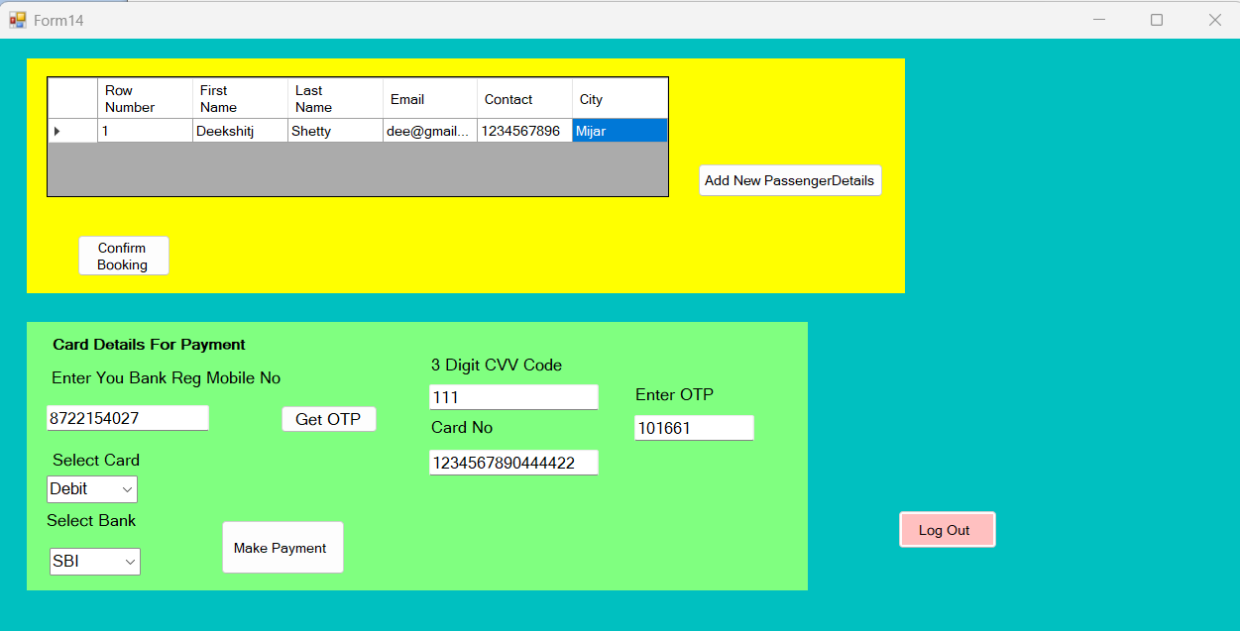

14. Payment Receipt 15 . Search For Available Buses
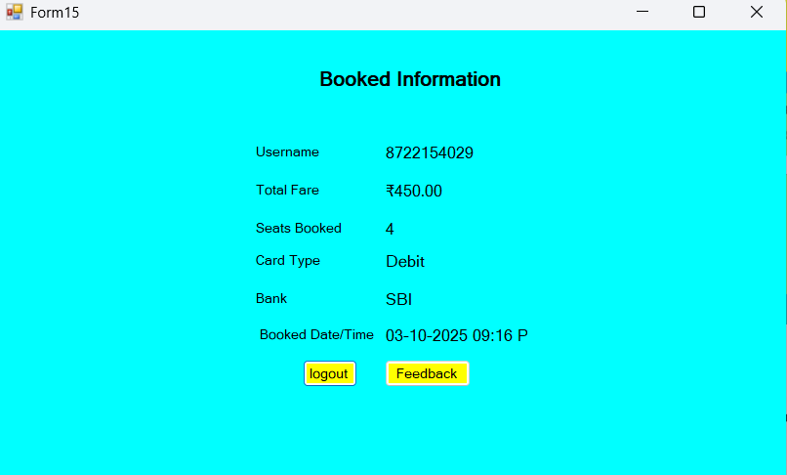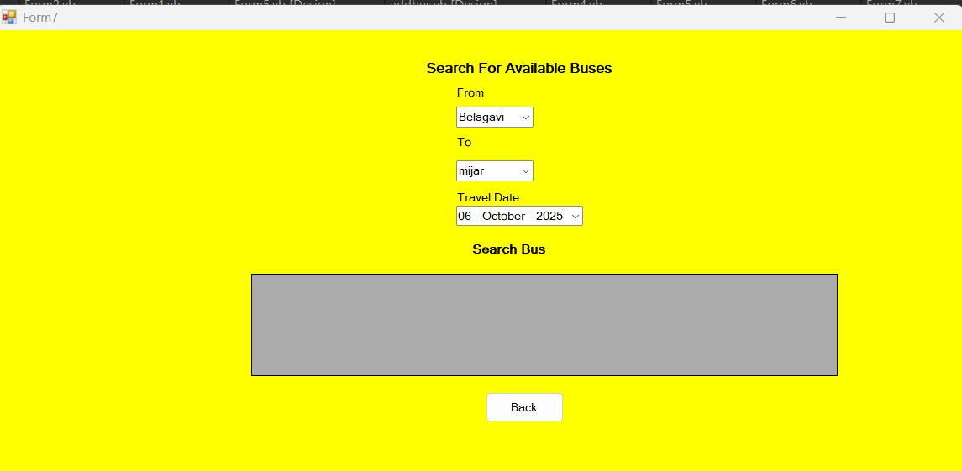

16 . User Feedback
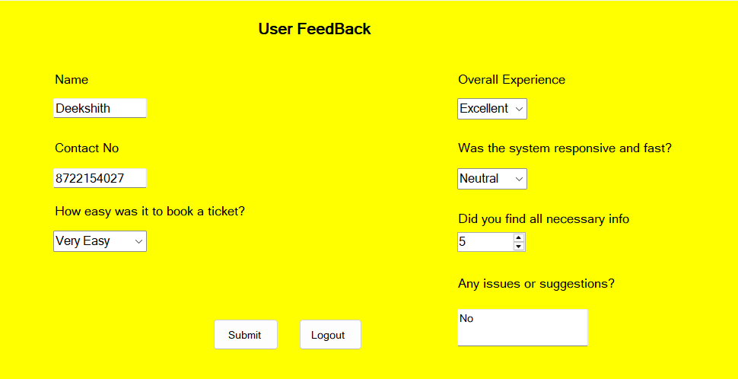

CHAPTER 7
CONCLUSION AND FUTURE SCOPE

7.1 Conclusion
7.1.1 Summary of the Project
The project “Online Bus Booking System” was developed as a Windows-based application using VB.NET as the frontend and MS Access as the backend database. The system provides a digital solution to the traditional manual bus booking process by offering modules for user registration, login, bus search, seat booking, payment validation, feedback collection, and admin management. This project successfully automated the entire workflow, making it more efficient, user-friendly, and error-free.
7.1.2 Results Achieved
- A fully functional system for both users and administrators was implemented.
- Secure login and registration modules were developed.
- Seat booking with restrictions (maximum 3 seats) was successfully integrated.
- OTP-based payment verification was simulated to enhance security.
- Feedback from users is collected and stored systematically.
- Administrators can add buses, manage routes, view bookings, and generate reports.
Thus, all the initial project objectives were met successfully.
7.1.3 Challenges Faced
- Designing the database relationships between buses, users, and bookings required careful planning to avoid redundancy.
- Implementing OTP verification logic in VB.NET was challenging but handled using random number generation and validation.
- Validations such as duplicate mobile number, email format, and seat booking limit were initially problematic but resolved through proper input checks.
- Integrating the feedback module with unique contact verification required database constraint handling.

7.1.4 Key Leanings
- Improved understanding of VB.NET Windows Forms application development.
- Gained practical knowledge of database design and integration with MS Access.
- Learned how to apply data validation and error handling in real-world applications.
- Enhanced skills in modular programming, testing, and debugging.
- Understood the importance of UI/UX design for usability.
7.2 Future Scope
- Integration with real-time payment gateways (Paytm, UPI, Debit/Credit cards).
- Migration from MS Access to SQL Server/MySQL for better scalability.
- Development of a mobile application for Android and iOS platforms.
- Addition of real-time bus tracking using GPS.
- Multi-language support for a wider user base.
- Advanced data analytics and reporting for administrators.
- Integration with other services like hotel booking or cab booking for end-to-end travel solutions.

CHAPTER 8
REFERENCES

• YouTube Tutorials
https://youtube.com/@technologykeeda?si=Khlj4LEmrgZx4QVZ
• Code Repositories
https://chat.openai.com/

